Customer Feedback Document:
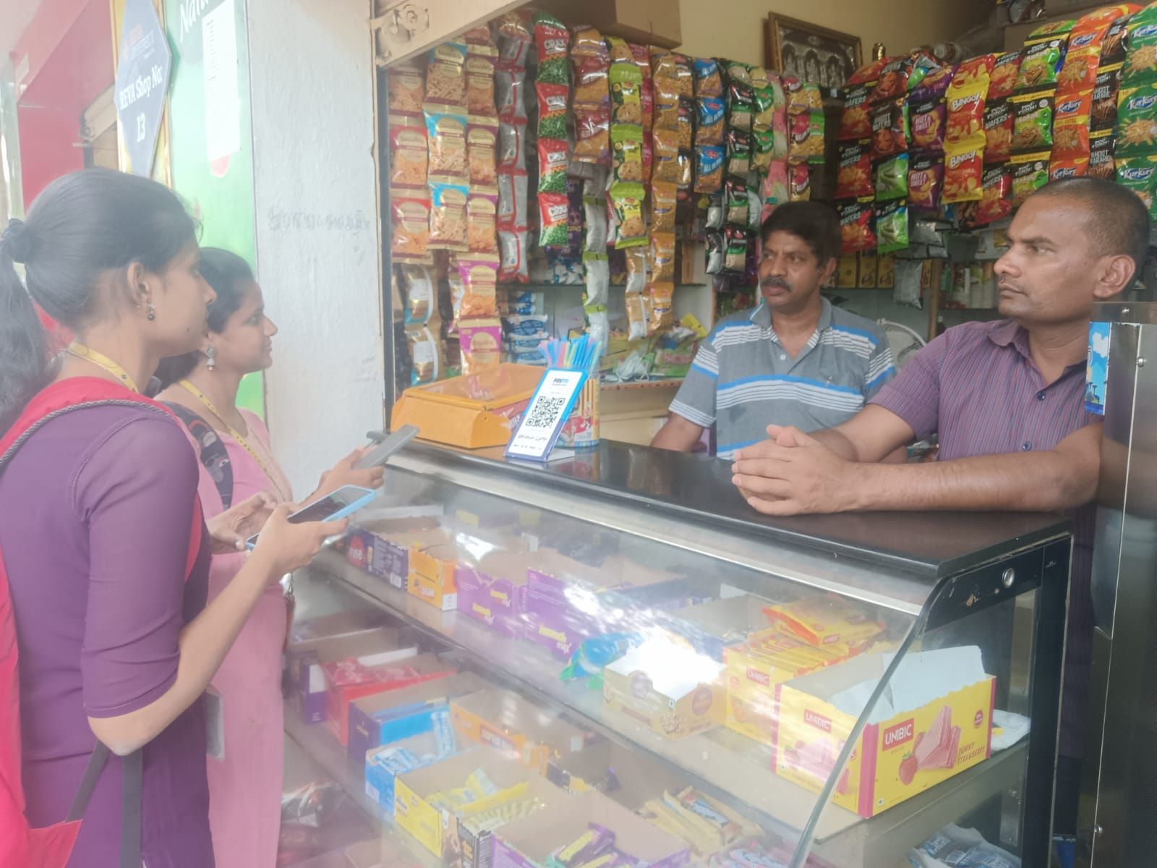

Name:
Role:
Firm:
Who handles GST:
Pain points:

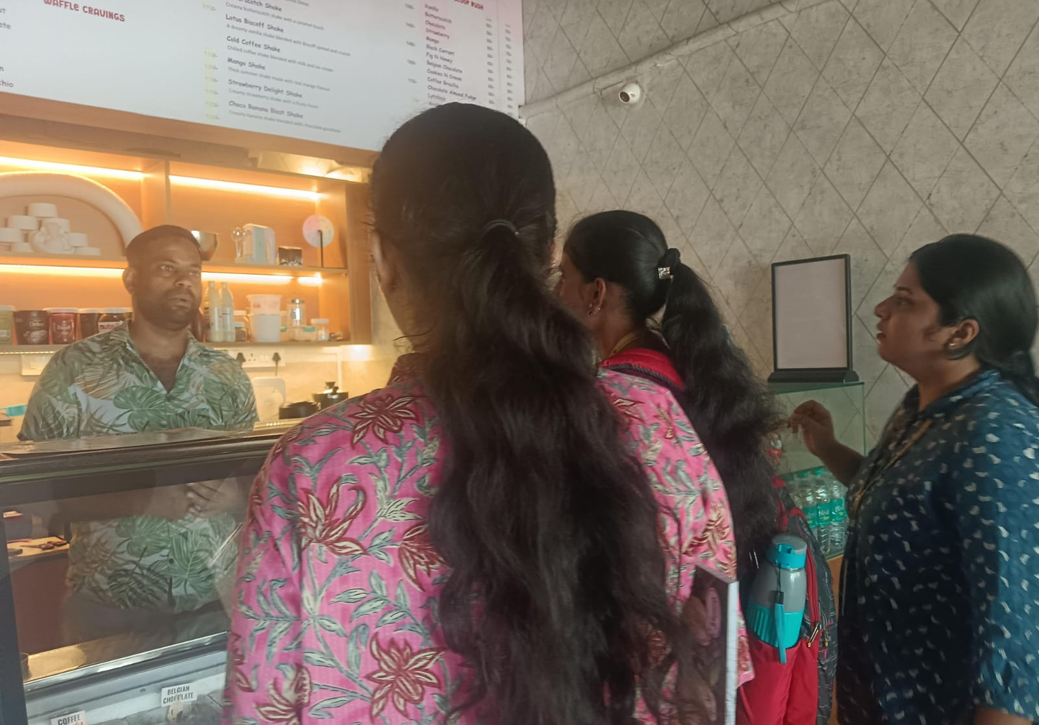

Name:
Role:
Firm:
Who handles GST:
Pain points:

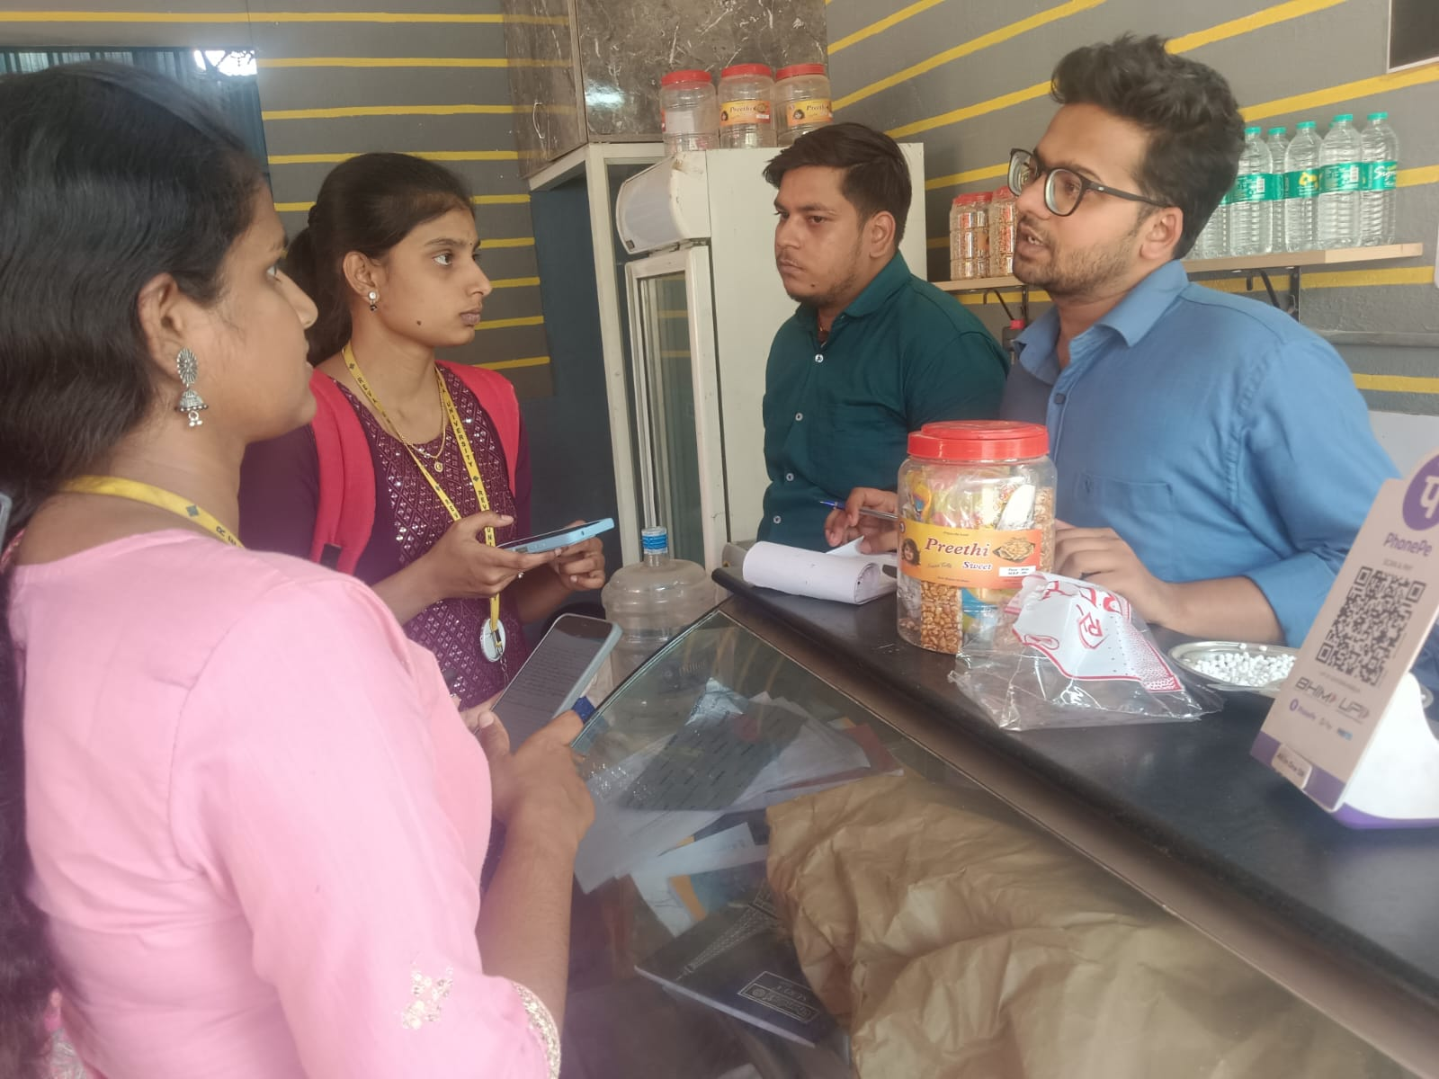

Name: Sayed Ali Khan
Shop Name: Limbu-Chilli Restaurant
Role: Owner
Firm: Small Restaurant
Who handles GST: Accountant(sometimes owner also involved)
Pain points: Daily transactions are handled by hand (manual entry)
Lack of proper digital system for accounting
Dependence on accountant for GST-related work
Confusion or inconsistency in GST handling
Time-consuming bookkeeping process
Possible errors due to manual work

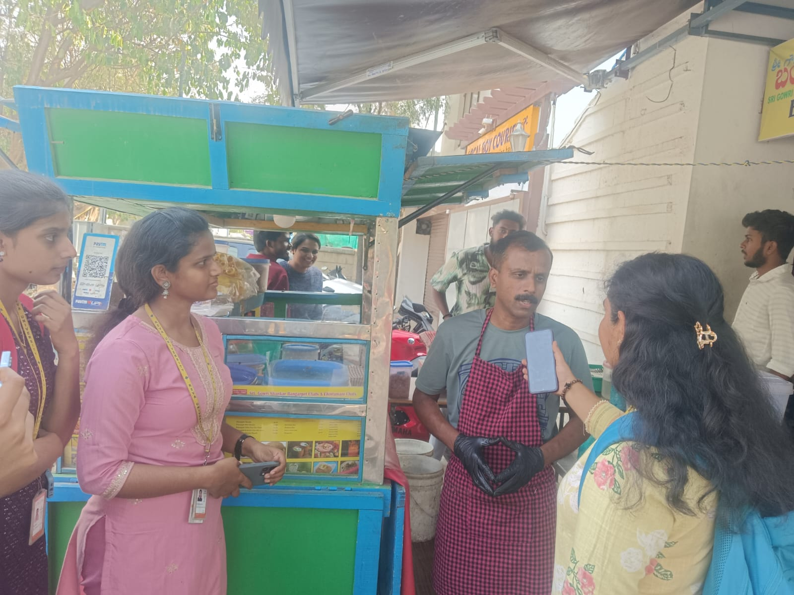

Name:
Role:
Firm:
Who handles GST:
Pain points:

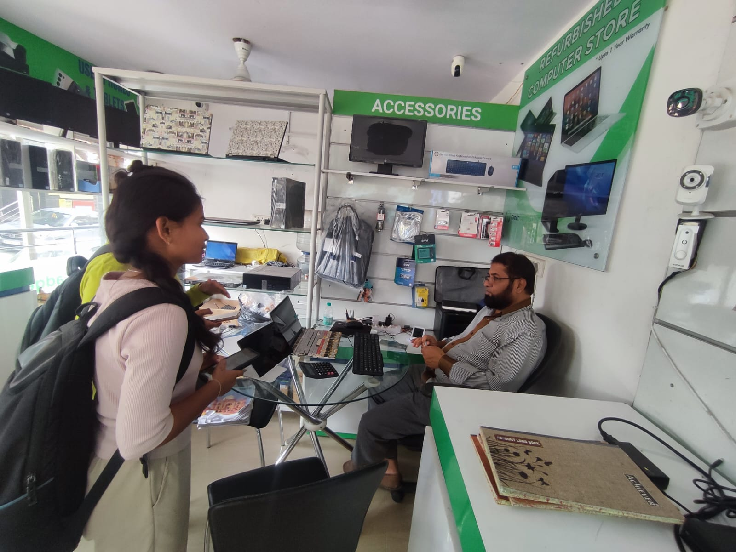

Name: Mohammed Rafi Sheikh
Shop Name: GreenGadgets Computer Store
Role: Shop Owner
Business Type: Refurbished Computer & Accessories Store
Who handles GST: Owner handles a little with the help of external CA support
Pain points:
- Multiple product categories with different GST rates and no unified billing system
- Refurbished and new accessories attract different GST rates, creating billing complexity
- Fully dependent on CA for GST filing with no real-time visibility into tax liability
- No integrated invoicing system, leading to errors and delays in monthly GST returns

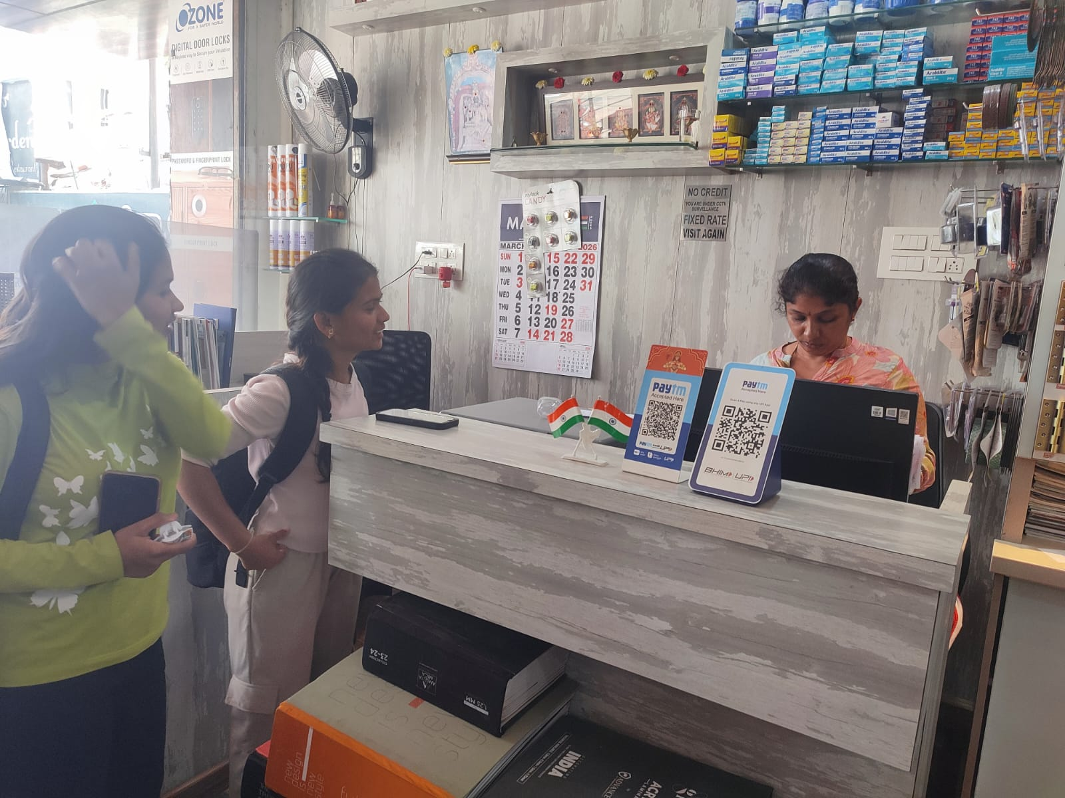

Name: Deepa Nair
Shope Name: Sagar Trading Company ( Door Locks & Hardware Store)
Role: Shop Owner
Business Type: Digital Door Locks & Hardware Store
Who handles GST: Owner herself handles the GST filling does around 10 filling a day depending on the number of invoices they get
Pain points:
- Managing GST across diverse hardware product categories (locks, electricals, accessories) with different tax slabs
- No dedicated accounting software; relies on manual billing and Paytm/BHIM UPI for payments
- Fixed-rate, no-credit policy makes it harder to issue proper GST invoices for every transaction



Name: Kiran Mehta
Shop Name:Aditya Pharmacy
Role: Pharmacist / Shop Owner
Business Type: Medical & Pharmacy Store
Who handles GST: External CA handles all GST filing and compliance
Pain points:
- Hundreds of medicine SKUs with varying GST rates (0%, 5%, 12%) making classification difficult
- Manual reconciliation of purchase invoices from multiple pharma distributors every month
- No automated billing system to track GST liability and ITC simultaneously

